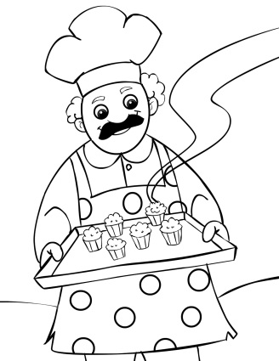Name_______________________________________

Home & Career Skills: Mrs. Cislo

**QUICK BREADS**

**Definition of quick bread:**  a leavened bread that uses a quick method of __________________. Leavened means that an ingredient has been added to make it rise.

What is added to a quick bread to make it rise?

__________________________________________________ or _____________________________________________

A **leavening agent** creates a reaction that gives off _________________ _________________ gas. This reaction causes little bubbles of gas to form and push up in the batter which makes the product rise.

**Examples of quick breads include:**

|  |  |  |
| --- | --- | --- |
|  |  |  |
|  |  |  |

**3 Types of quick breads:**

1. ___________________ ____________________- the dough is thick enough to be kneaded with your hands. Kneading is a way to manipulate the dough with your hands to create texture. Example:_______________________________________________________
2. ___________________ ____________________-the batter is dropped from a spoon. It would

be very sticky to your hands. Example:__________________________________________

1. ___________________ _____________________- the batter is thin and runny so it must be poured. Example: ___________________________________________.

**Quick breads can be served for most meals.**

**Meal Example Example**

|  |  |  |
| --- | --- | --- |
| Breakfast |  |  |
| Lunch/dinner |  |  |
| Dessert |  |  |

*Main ingredients* in quick breads and the function of each ingredient.

Choices: sugar, flavorings, baking powder/baking soda, shortening,

Eggs, liquid, flavoring, flour

**Ingredient Function**

|  |  |
| --- | --- |
|  | Gives framework or structure. |
|  | Adds flavor, color, moistness and makes the ingredients stick together. Start off as a liquid, but when heated turns to a solid. |
|  | Added to a product to make it rise. |
|  | Helps ingredients react with each other and makes the ingredients stick together. This could be milk and water. |
|  | This could be Crisco or butter. It adds richness, tenderness, moistness and flakiness. |
|  | Gives a sweet flavor, can help brown the tops. |
|  | Extra ingredients like vanilla, almond extract or lemon extract. Enhances or adds new flavor. |

**General questions:**

1. What do you think would happen if you added too much liquid to a muffin?

2. What do you think would happen if you didn’t add the egg(s) to a muffin?

3. What would happen if you added too much flour to your muffins?

4. If you forgot to add the sugar to your muffins what would happen?